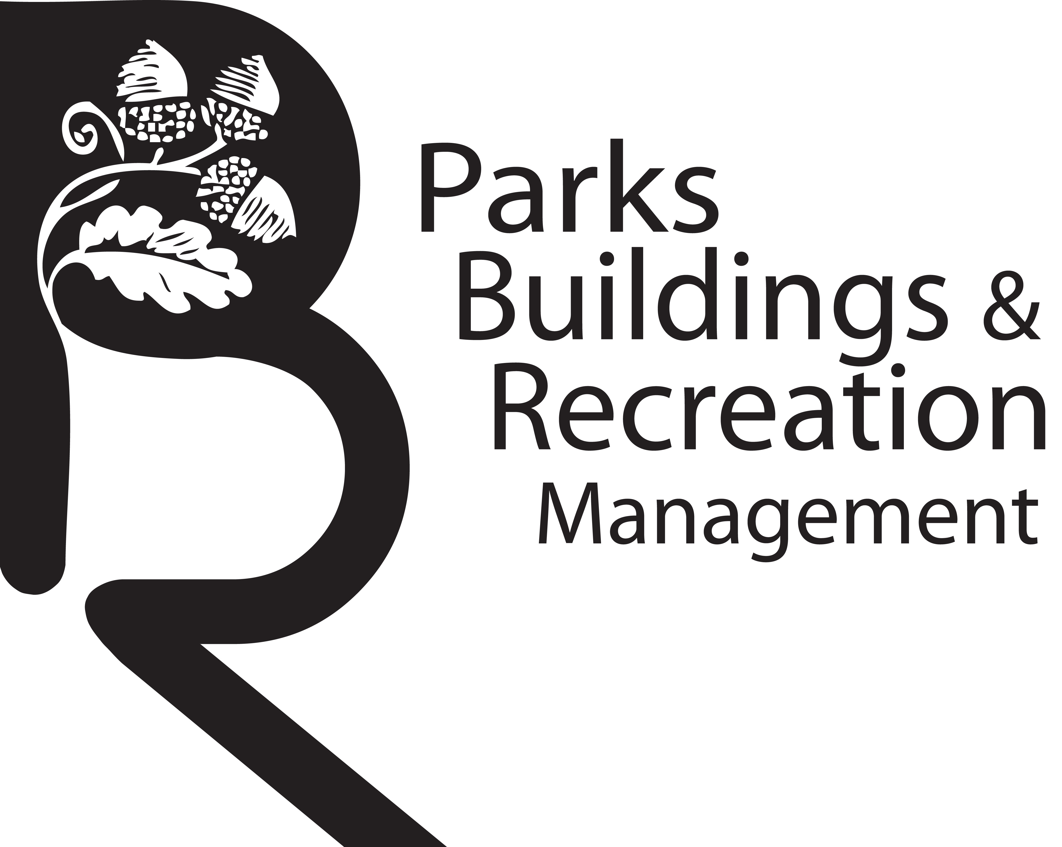

Parental Consent Form
TENNIS CLINICS
I ____________________________________, hereby give permission for my child(ren) (hereby referred to as “Participant(s)”), to attend and participate in Tennis Clinics at Forest Park, Springfield, Ma.
LIABILITY RELEASE: In consideration of Moving on Up with Tennis and Education Inc. allowing the Participant(s) to participate the above mentioned tennis clinics, I, the undersigned, do hereby release, forever discharge and agree to hold harmless Moving on Up with Tennis and Education Inc., its staff, volunteers and teachers (collectively herein the “Organization”) from any and all liability, claims or demands for accidental personal injury, sickness or death, as well as property damage and expenses, of any nature whatsoever which may be incurred by the undersigned and the Participant(s) while involved in the children/youth activities. The undersigned further hereby agrees to hold harmless and indemnify said Organization for any liability sustained by said Organization as the result of the negligent, willful or intentional acts of said Participant(s), including expenses incurred attendant thereto.

MEDICAL TREATMENT PERMISSION: I authorize an adult, in whose care the minor has been entrusted, to consent to any emergency x-ray examination, anesthetic, medical, surgical or dental diagnosis or treatment and hospital care, to be rendered to the minor under the general or special supervision and on the advice of any physician or dentist licensed under the provisions of the Medical Practice Act on the medical staff of a licensed hospital or emergency care facility. The undersigned shall be liable and agrees to pay all costs and expenses incurred in connection with such medical and dental services rendered to the aforementioned child or youth pursuant to this authorization.

_______________________________________ x___________________________________ ____________
Name of parent/guardian Signature of parent/guardian Date

Youth Information
Name _____________________________ Grade _________ DOB __________ Male/Female
Name _____________________________ Grade _________ DOB __________ Male/Female
Name _____________________________ Grade _________ DOB __________ Male/Female
Parent/ Guardian Information (please print)
Name(s) ______________________________________________________________________
Email(s) ______________________________________________________________________
Address ______________________________________________________________________
List all phone numbers where the parent/guardian can be reached (type: i.e. home, cell)
Name__________________________ #_______________________ Type? _________
Name__________________________ #_______________________ Type? _________

Emergency Contact
Name_________________________ #_______________________ Relation? _____________
Name_________________________ #_______________________ Relation? _____________

Moving on Up with Tennis & Education Inc.
PHOTO RELEASE FORM
I grant to Moving on Up with Tennis & Education Inc., its representatives and employees the right to take photographs of me and my child(ren). I authorize Moving on Up with Tennis & Education Inc., its assignees and transferees to copyright, use and publish the same in print and/or electronically.
I agree that Moving on Up with Tennis & Education Inc., may use such photographs of me with or without my name and for any lawful purpose, including for example such purposes as publicity, illustration, advertising, and web content.

Name of child/children

_______________________________________ x___________________________________ ____________
Name of parent/guardian (PLEASE PRINT) Signature of parent/guardian Date

